1. **Design document**

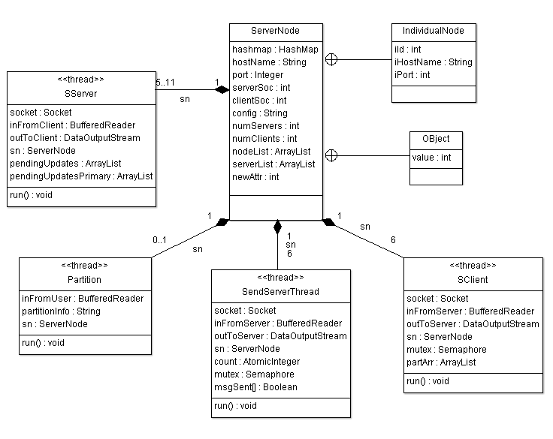

Figure1 Class diagram for server

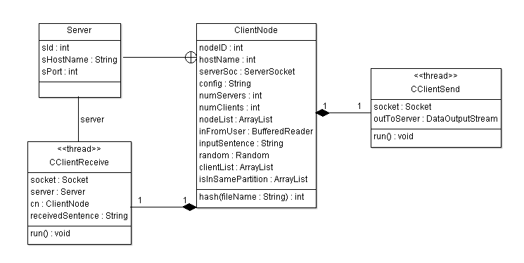

Figure2 Class diagram for client

**Message statistics:**

Numbers of messages for each insert operation: At most 3 messages to 3 servers (n messages for n replicas)

Number of messages for each read operation: At most 1 messages to one of the 3 servers (1 message for n replicas)

Number of messages for each update operation: 3 messages from client + 2 more messages between servers (n + O(n-1) messages for n replicas)

Partition Message: Node 0 communicates to all the other nodes. (N servers + S clients)

**Results:**

Concurrent inserts from multiple clients

Concurrent reads from multiple clients

Concurrent updates of inserted values from multiple clients

Storing multiple inserted and updated values from multiple clients

Restricted access to write, read and updates based on partitions (only if 2 servers are reachable)

Total ordering of updates for maintaining the order of execution of updates

Edge conditions check for inserting same objects, updating without inserting and reading without inserting

**Screenshot of the results: Client without partitioning**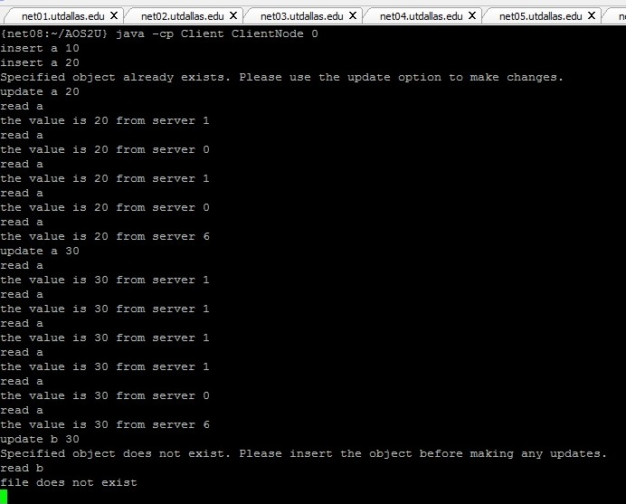  
  
**Primary Server without partitioning**

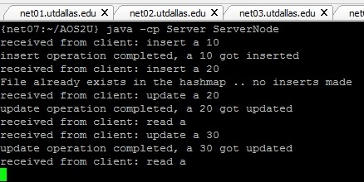

**Secondary Server 1 without partitioning**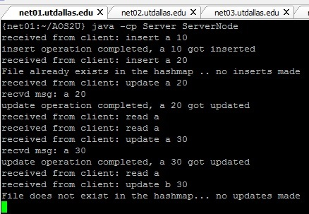

**Secondary Server 2 without partitioning**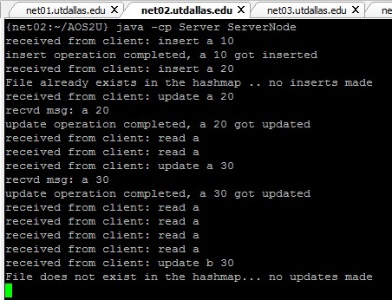

**Client after partitioning (456 in one partition)**

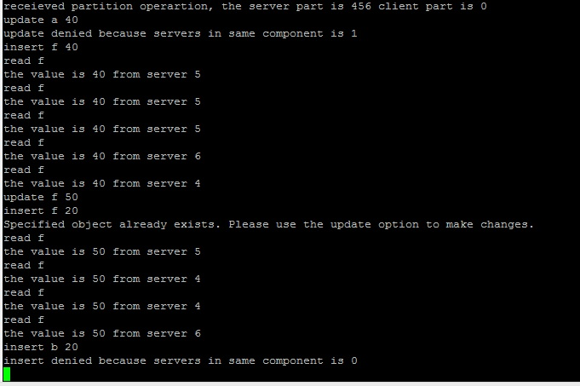

**Primary Server after partitioning**

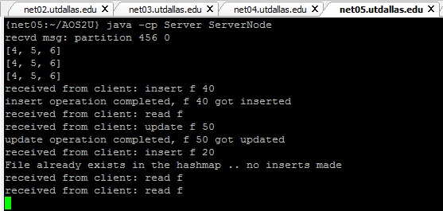

**Secondary Server 1 after partitioning**

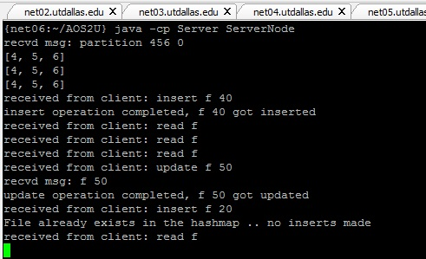

**Secondary Server 2 after partitioning**

